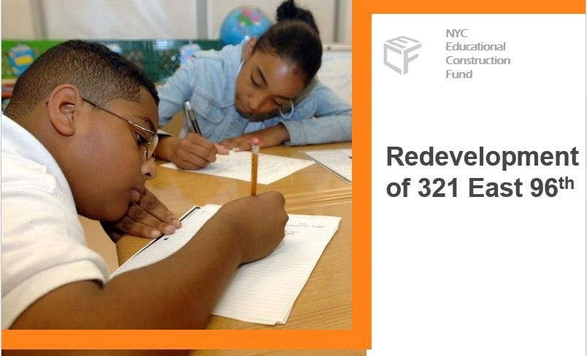 | Redevelopment of 321 East 96th Street  DEIS SCOPING MEETING  JUNE 29, 2016  PARK EAST HIGH SCHOOL

The Educational Construction Fund (ECF)
- ECF is a NYS Public Benefit Corporation tasked with building new NYC Department of Education (DOE) public schools through mixed-use development projects, without the use of DOE capital funding
- ECF has developed 18 projects since the 1970’s – most recently with PS 59/High School of Art and Design at East 57th and Second Avenue
- ECF works with the DOE and the New York City School Construction Authority (SCA) to identify schools and communities that need improved school facilities, and whose potential value can allow a private partnership to pay for and construct the buildings within a viable financial model

Planning for 321 East 96th Street
- September 2013 - ECF met with local elected officials staff and Community Board 11 to introduce a proposed new ECF project for 3 sites including 321 East 96th Street
- After consideration of competitive bidders and available locations to keep the schools active during construction, the decision was made to redevelop COOP Tech with AvalonBay.
- May 2014– ECF met with Speaker Mark-Viverito staff to update on project development and address the Speaker’s and community’s specific requests for any proposed project:
  - New Schools Benefitting the Local Community
  - Affordable Housing
  - Economic Development
  - Job Training and Employment Opportunities
- COOP Tech, The Heritage School and Park East High School lack available space for growth and/or appropriate facilities for high student achievement.

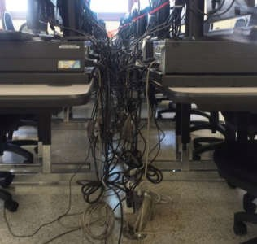
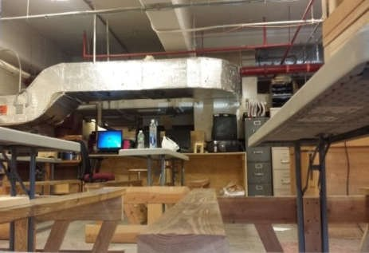
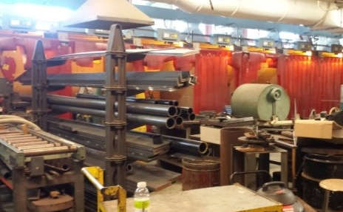
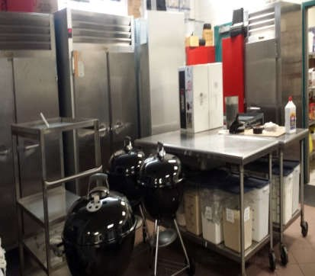
COOP Tech
- Cramped learning environment
- Additional shops for popular trades (welding, carpentry, automotive, culinary) cannot be accommodated in current space
- Inadequate electrical and ventilation system
- Lack of central efficient storage facilities for trade equipment and supplies

Current School Constraints
 COOP Tech, The Heritage School and Park East High School
lack available space for growth and/or appropriate facilities

for high student achievement.
The Heritage School – 1680 Lexington Ave
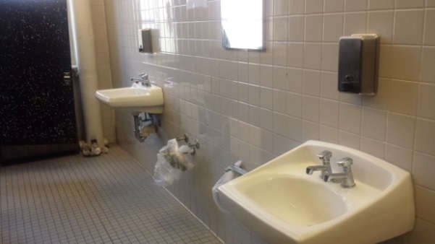
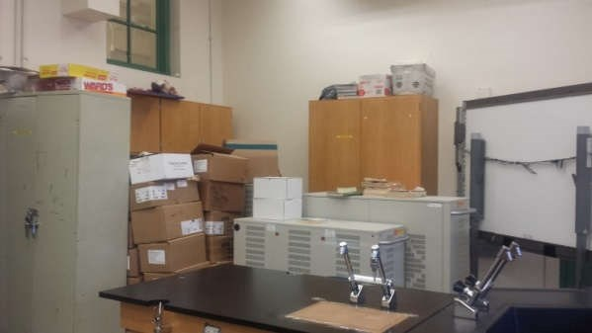
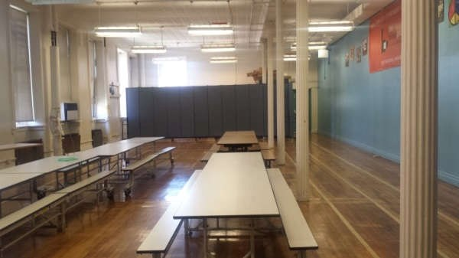
- Cramped learning environment

- Limited growth at Julia de Burgos Cultural Center
- Lack of appropriate cafeteria, gym and private counseling space
- Lack of storage facilities
Park East High School – 230 E. 105th Street
- Cramped learning environment
- Confined spaces – narrow halls and classrooms
- Gym serves as both gym and auditorium.
- Cafeteria doubles as art room.
- Lack of storage facilities
- Not fully ADA-accessible

- Marx Brothers Playground, est. 1941

New Playground
  - Built by DOE for use by surrounding schools
  - Serves as a Jointly Operated Playground (JOP) for use by the schools and the community
JOPs are under title to DOE
- Since 2008, western portion of the Playground has been used for MTA’s Second Avenue staging
- Remainder of playground is primarily used as a ballfield and soccer field
- Project will completely rehab existing playground, while keeping its original size
- Continued input from DPR, CB11, and local community on design of the playground
- Publicly-traded company with a national portfolio of market rate and affordable housing.

AvalonBay Communicates, Inc.
- AvalonBay’s NYC portfolio consists of nearly 5,000 apartment homes in 11 buildings located in Queens, Brooklyn and Manhattan.
- AvalonBay has been developing and managing mixed-income inclusionary housing communities in the NYC metro since 1986 and high-rise buildings in New York City since 1998. Affordable housing development includes 500 affordable units in Manhattan and over 1,650 in the region.
- AvalonBay is an integrated real estate company that includes extensive design, project finance, construction, and property management capabilities and an excellent track record of development in New York City.
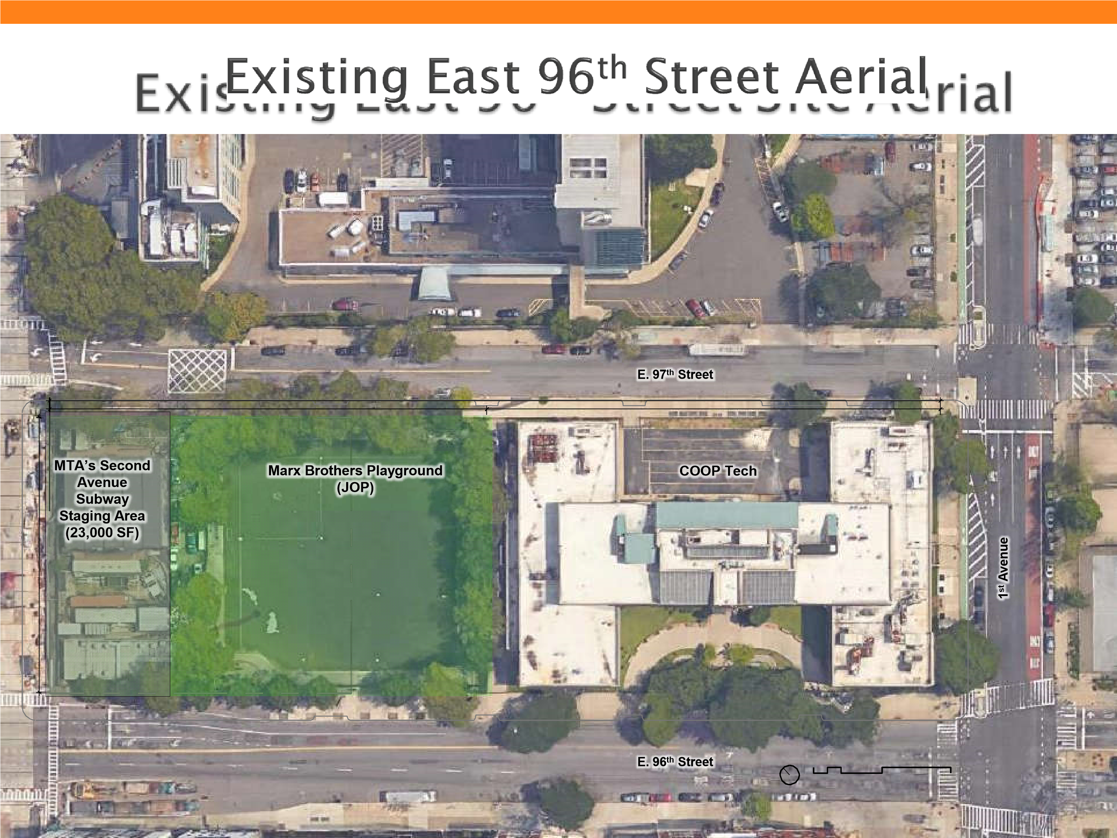

Scope of Project
- Approximately 1.3M gross square feet (gsf)
  - Two School buildings = ~270K gsf
COOP Tech, The Heritage High School & Park East High School
  - Residential = ~1.0M GSF
68 stories
~1,100 – 1,200 apartments
  - Retail = ~22K gsf
- Permanent Affordable Housing
  - 30% of total units– all rental (~330 - 360 affordable units)
  - Affordable to households averaging 60% of AMI
- Relocation and Reconstruction of the Marx Brothers Playground
- Project is funded by ECF and AvalonBay
Pr

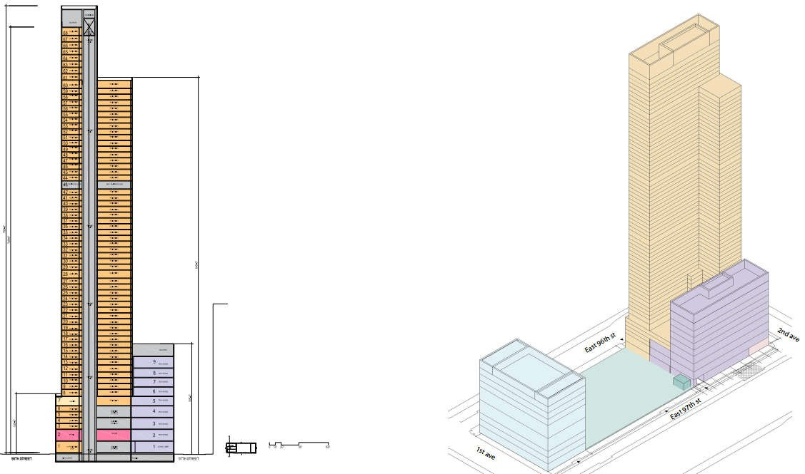
Heritage High School and
Park East High School
COOP
Tech
North-South Section
- Project is funded by ECF and AvalonBay– NOT DOE
- Construction of a new, better equipped school facility for COOP Tech, at NO cost to the City
- Creation of an new school building to house The Heritage High School and Park East High School, at NO cost to the City  300+ units of Permanent Affordable Housing.
- Revitalization and reconstruction of the Marx Brothers playground
- Apprenticeships for COOP Tech students with AvalonBay and its contractors
- Quality job creation
  - 700+ construction jobs
  - 40+ permanent in residential; 50+ retail
  - Focus employment with neighborhood through HireNYC and local workforce partners
- Addresses capital and capacity needs facing East Harlem schools
- Allows rezoning to assist replacement of aging and inadequate school facilities
- Expands Career and Technical Education programs at COOP Tech to meet the demand of high growth, well paying/strong benefit job fields
- Allows for superior learning environment for Heritage and Park East High Schools
- Creates 300+ permanent affordable housing with varied levels of affordability
- Relocates and rebuilds Marx Brothers Playground to help meet the needs of existing residents and schools
- Increases employment opportunities for East Harlem residents.
- Amendments to the Zoning Map
  - Rezone a 100’ portion east of 2nd Avenue from R10A/R7-2 to a C2-8 District
  - Rezone remainder of Block 1668 from R7-2/R10A to a R10 District
- Amendments to the Zoning Resolution
  - To allow distribution of lot coverage
  - To establish a Mandatory Inclusionary Housing designated area
- Special permits
  - To allow distribution of lot coverage and waiver of height and setback restrictions
  - To reduce parking requirements applicable to non-income restricted residences
- Certifications to modify restrictions on location of curb cuts
- Certification that a transit easement is not required
- Approval of a home rule message by the New York City Council
- Legislation by the New York State Legislature to authorize the alienation and disposition to ECF of the existing JOP playground, and its replacement with an equivalent amount of JOP playground
- Transfer of the City-owned property
  - The City would convey the site to ECF, which would lease a portion of the property to AvalonBay.
  - ECF would convey the schools to the City and re-convey control of the JOP playground to DOE and DPR
- Issuance of tax-exempt bonds by ECF to facilitate construction of the schools.
SEQRA DEIS follows City Environmental Quality Review (CEQR) Technical Manual guidance and screening threshold procedures

Areas of Analysis
- Land Use, Zoning and 7. Urban Design and 14.Air Quality
Public Policy Visual Resources 15.Greenhouse Gas
- Socioeconomic 8. Natural Resources Emissions Conditions 9. Hazardous Materials 16.Noise
- Community Facilities 10.Water and Sewer 17.Public Health and Services Infrastructure 18.Construction Impacts
- Open Space 11.Solid Waste and Mitigation
- Shadows Sanitation Services Alternatives
- Historic & Cultural 12.Energy
Resources 13.Transportation
Highlights on Areas of Analysis:
- Land Use, Zoning, and Public Policy
    - Consistency with area land use and zoning
    - Consistency with community plans – East Harlem Neighborhood Plan  Community Facilities and Services • Public school and daycare demand
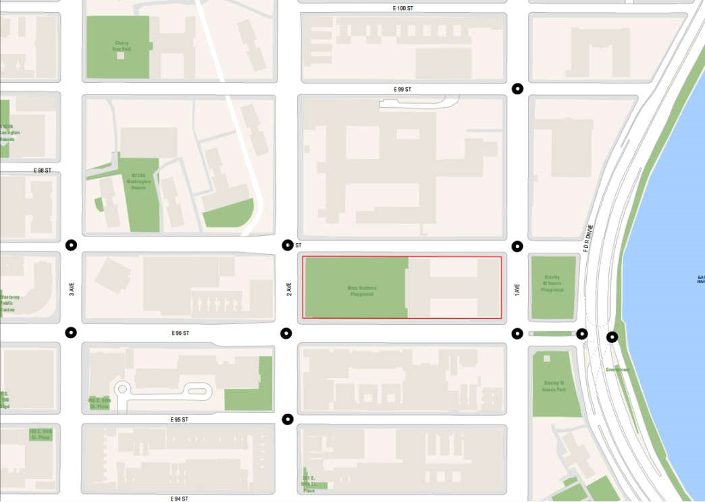
- Open Space  Transportation
    - Detailed traffic analysis
    - Parking demand and circulation
    - Transit and pedestrian safety
Highlights on Areas of Analysis:
- Air Quality and Noise  Construction Impacts
    - Construction staging
    - Maintenance and Protection of Traffic
    - Noise and vibration
    - Minimizing effects on existing schools and Metropolitan Hospital operations
- Mitigation
- Alternatives
•
Public
Announcement
•
Outreach to elected
officials/ community
input and support
•
Begin SEQRA/EIS
phase
•
ULURP
•
Alienation of
playground
•
AvalonBay and
ECF
design
schools and
residential tower
•
MTA vacates
playground
•
Construction of
new COOP Tech
•
New
COOP Tech
opens
•
Demolition of
existing COOP
Tech
•
Construction of
additional schools
•
Construction of
playground
•
Opening of
additional schools
and playground
2016
2017
2018
-
2020
2021
-
2022
2023
•
Completion of
residential tower
and retail
- Comments on the Draft Scope of Work
- Written comments will be accepted until 5:00 p.m. on July 11, 2016
- Comments may be submitted at the scoping meetings, by email to E96Street@schools.nyc.gov, or by regular mail to the address below:
Jennifer Maldonado, Executive Director
New York City Educational Construction Fund
Re: COOP Tech @ East 96th Street
30-30 Thomson Avenue, 1st Floor
Long Island City, NY 11101

