Accessibility Full Self-Audit Procedure

Part 1 – Automated Testing
This process should be used by all digital properties used by the NYC DOE. Every owner of a website and application is to submit the results of their self-audit to the Completed Full Self-Audit Reports in SharePoint. This self-audit must be performed semi-annually (November-January and May-July) to verify compliance.

Part 1 – Automated Self-Audit Procedure (Tab1)
Reminder: Automated testing can catch only 30% of all possible TYPES of errors.
- Watch the 15-minute Automated Self-Audit Training Video
- Add the WebAIM WAVE Chrome extension – WAVE Evaluation Tool—to your Chrome Browser.
- Open the landing page (or the page after the login screen, if you have one) plus 5 other pages. (6 pages in total.)
- Download a copy of the Accessibility Full Self-Audit Template to log your audit results and calculate your site’s or application’s score.
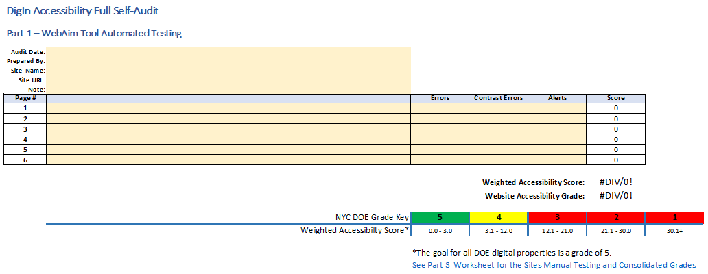
- Enter the following information:
  - Audit Date
  - Prepared By (your/owner’s DOE email address)
  - Site’s name
  - Site’s URL (https://...)
- Use the WebAIM Wave Extension on 6 pages:
  - Landing page
  - And 5 other pages of your choice.
    - Add the 5 URLs and associated Wave scores for (Errors, Contrast, and Alerts) in the spreadsheet.
- The score will be automatically calculated based on the 5 individual page ratings.
Part 2 – Manual Testing (Response Values – Yes or No) (Tab 2)
Reminder: Automated testing only catches 40% of the TYPES of errors. The remaining 60% must be tested manually.
- Watch the manual testing training video https://digin.nyc/manualtestpres for more information on each component.
- Answer “Yes” or “No” to every question.
  - Every “Yes” counts as a “1.”
  - “No’s are not counted.
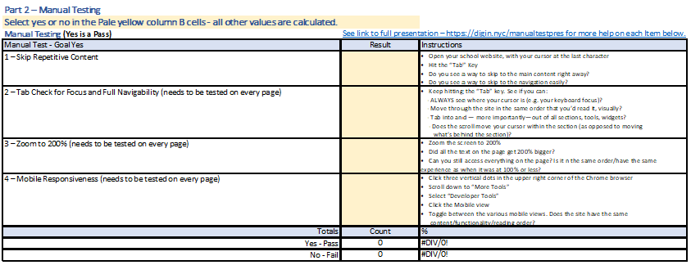

1 – Skip Repetitive Content
Open your school website. Place your cursor to the right of the URL’s last character. Hit the "Tab" Key
- Do you see a way to skip to the main content right away?
- Bonus: Do you see a way to skip to the navigation easily?
2 – Tab Check for Focus (test on every page)
Keep hitting the “Tab” key. See if you can:
- ALWAYS see where your cursor is (e.g. your keyboard focus)?
3 – Tab Check for Order (test on every page)
Keep hitting the “Tab” key. See if you can:
- Move through the site IN THE SAME ORDER that you’d read it, visually?
4 – Tab Check for Full Nav, Widget, and Embed Navigability (test on every page)
Keep hitting the “Tab” key. See if you can:
- Tab into and — more importantly—out of all sections, tools, widgets
5 – Tab Check for Scrolling Accuracy (test on every page)
Test the scrolling:
- Does the scroll move your cursor within the section (as opposed to moving what’s behind the section)?

6 – Zoom to 200%
Zoom the screen to 200%.
- Did ALL the text on the page get 200% bigger? Even buttons and menu items?
- Is all the same content still on the page?
  - If some, but not all, of the content is on the page, answer “No.”
- Can you still access everything on the page?
  - Is it in the same order as when it was at 100% or less?
  - Do you have the same experience as when it was at 100% or less?

4 – Mobile Responsiveness
- Click three vertical dots in the upper right corner of the Chrome browser
- Scroll down to "More Tools"
- Select "Developer Tools"
- Click the "Mobile view"
- Toggle between various mobile views: Does the site have the same content/functionality/reading order?

Part 3 – Other Considerations (Response Values – Yes or No) (Tab 2)
Answer “Yes” or “No” to every question:
- Every “Yes” counts as a “1.”
- “No’s are not counted.
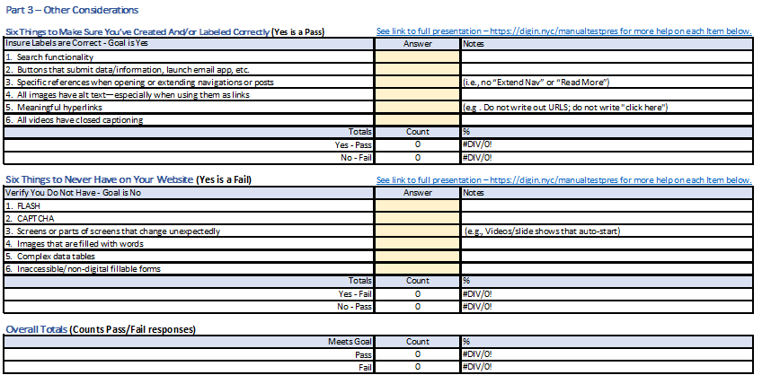

Six Things to Make Sure You've Created And/or Labeled Correctly (Yes is a Pass)
- Search functionality
- Buttons that submit data/information, launch email app, etc.
- Specific references when opening or extending navigations or posts (i.e., no "Extend Nav" or "Read More")
- All images have alt text—especially when using them as links
- Meaningful hyperlinks (e.g. Do not write out URLS; do not write "click here")
- All videos have closed captioning; videos for families have the CC available in the DOE’s 10 official languages

Six Things to Never Have on Your Website (Yes is a Fail)
- FLASH
- CAPTCHA
- Screens or parts of screens that change unexpectedly (e.g., Videos/slide shows that auto-start)
- Images that are filled with words
- Complex data tables
- Inaccessible/non-digital fillable forms
Part 4 – Consolidated Score Card (Tab 3)
The consolidated score care summaries and calculates the information provided in tabs 1 and 2. The calculation is:
- Calculation = ((Part 1 WebAIM Testing Grade)*40%)+ ((Part 2 &3 Manual Testing Grade)* 60%))
  - Part 1 accounts for 40% of the sites overall score
  - Parts 2 and 3 together account for 60% of the overall score.
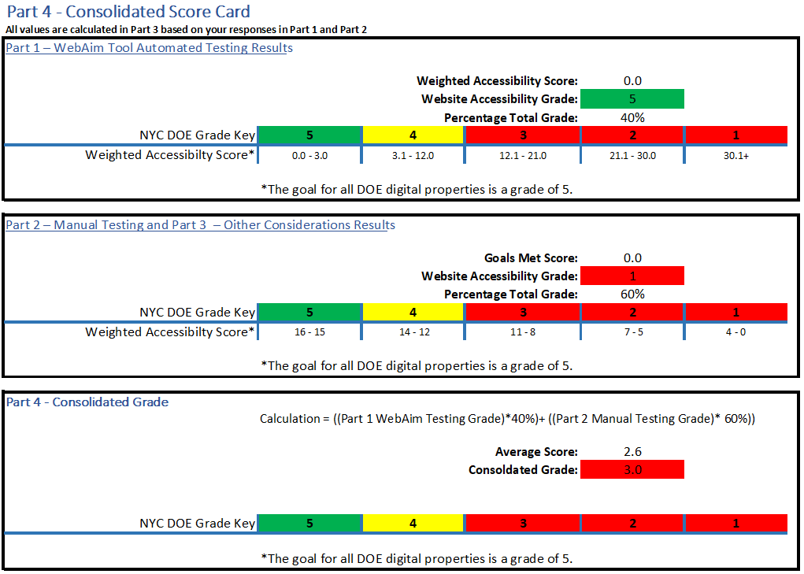

Save Your Completed Self-Audit
Save the spreadsheet with a naming convention of Full-Self-Audit (-Site-Name-) (Audit Date).xlsx at Completed Full Self-Audits.
NOTE:
- There is no .org, .com, or .net in the file name.
- Hyphens (not underscores) are needed between words/dates to make it accessible
- A sample name for a site whose audit was completed on March 1 would be:
  - Full-Self-Audit-PS123-03012022.

Additional Information
Visit the InfoHub If you would like more information on digital Accessibility, Training, or email us at DigitalAccesibilty@schools.nyc.gov.

