Printable Daily Schedule Cards (horizontal): with pictures, Spanish/English
The following pictures cards can be printed, cut and posted in the classroom to create a visual schedule.
Remember to print one sided and make the schedule sturdy so children can use it independently. For further guidance on creating a visual schedule see Tools of Autonomy for Three Year Old Classes in Exploration One: Our Community.
When creating a dual language schedule, use a separate color for each language. Coordinate colors accordingly throughout the classroom.
Note that language may vary based on dialect or country. Use the appropriate words and phrases for the children in your classroom.

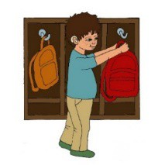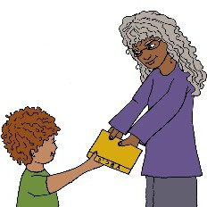 | Desempacar Unpack
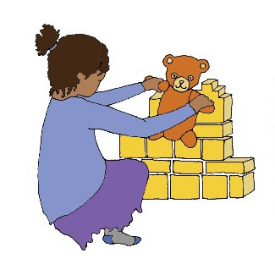 | Actividades al llegar al salón de clase  Arrival Activities
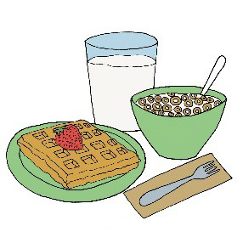 | Desayuno Breakfast

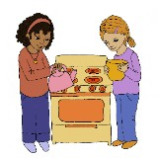
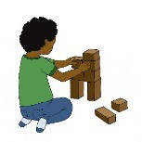

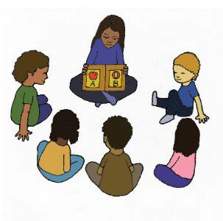 | Grupo grande Large Group
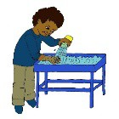  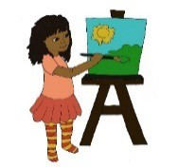 | Centros de juego Centers
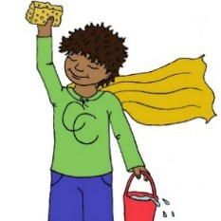 | Limpieza Clean-Up

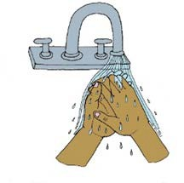 | Lavarse las manos Handwashing
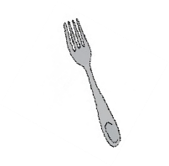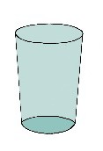 | Almuerzo Lunch

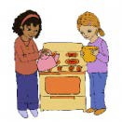

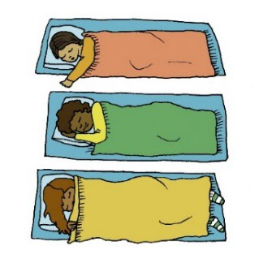 | Descanso Rest
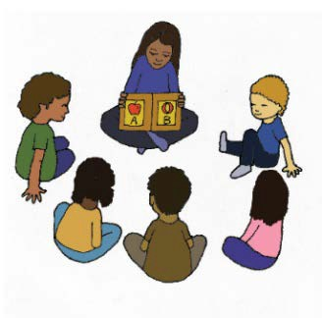 | Hora del cuentacuentos  Story Time
 | Centros de juego Centers

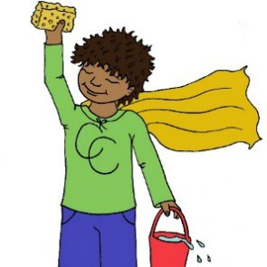 | Limpieza Clean-Up
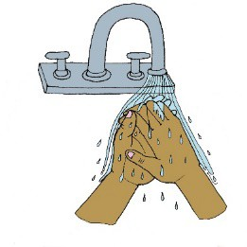 | Lavarse las manos Handwashing
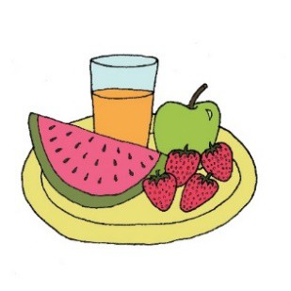 | Refrigerio Snack

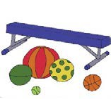  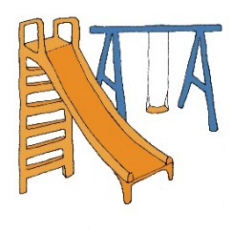 | Motricidad Gruesa Gross Motor
 | Reunión de despedida Closing Meeting
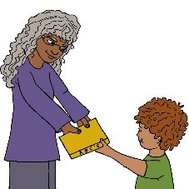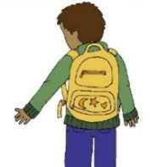 | Empacar/ Despedida  Pack-Up/ Dismissal

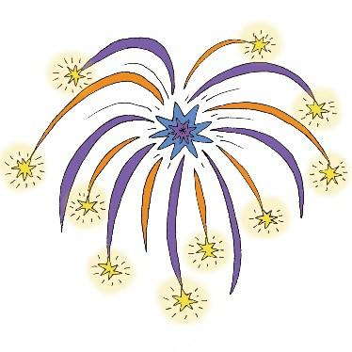 | Celebraciones Celebrations
 | Actividades especiales Specials
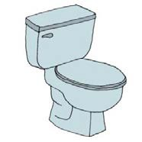 | Baño Bathroom

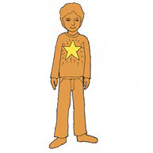 | Visitante especial Special Visitor
Cambio de programa
Schedule Change

