Share your ideas for rebuilding Marx Brothers Playground!
Monday, October 24, 2016
6:30-8:30 p.m.
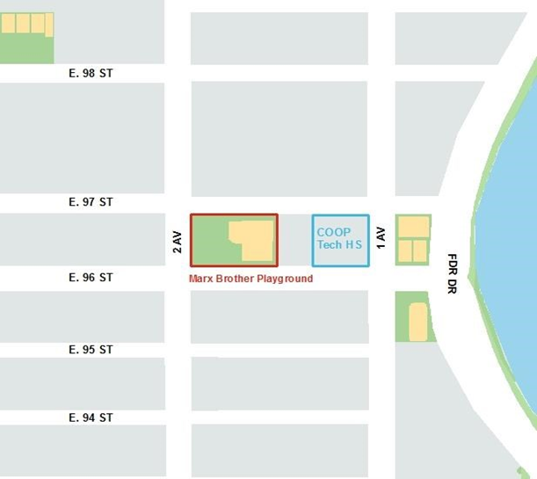
Coop Tech HS
321 E. 96th Street
New York, NY 10128
Marx Brothers Playground, located on 96th Street between 2nd Ave and 1st Ave, will be reconstructed. Give us your feedback on the kind of playground you need and want to see! Refreshments will be served and kids are welcome.
For more information or to participate, email elizabeth.ernish@parks.nyc.gov, or call 212-360-3463.

