Building Blocks Curriculum Materials

Building Blocks Materials in the Kit
2 cardboard game boards (game pieces are counters)  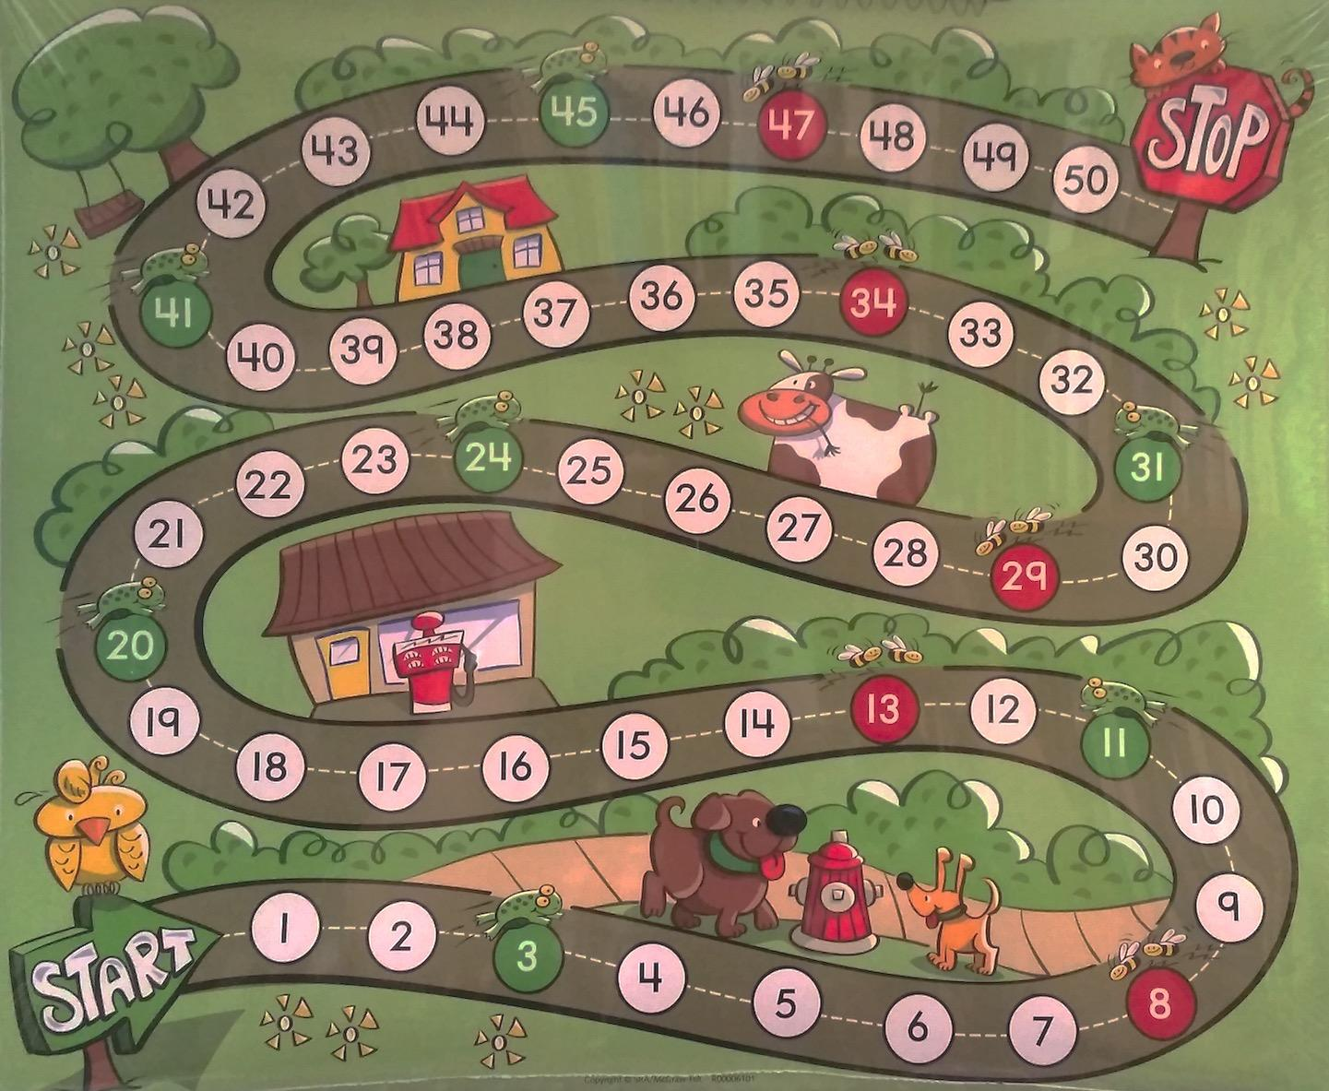 | 3 bags of yellow/blue foam shapes  (Shape Sets) 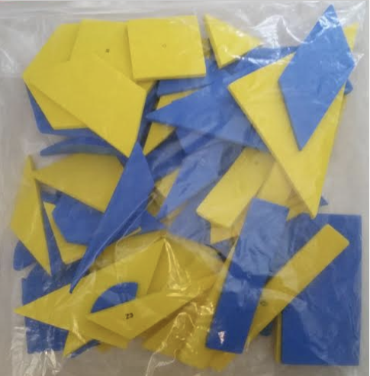 | 5 bags of Unifix cubes (connecting cubes)  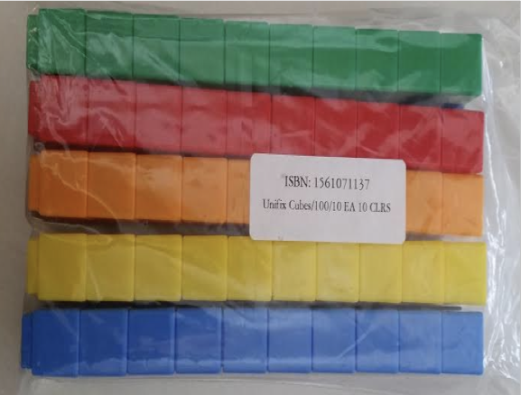 | 1 bag of numeral dice (3 red, 3 blue, 3 yellow, 3 green)  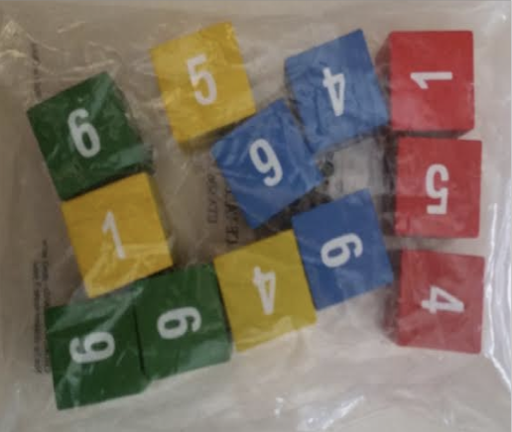 | 25 red dice numbered 0-5  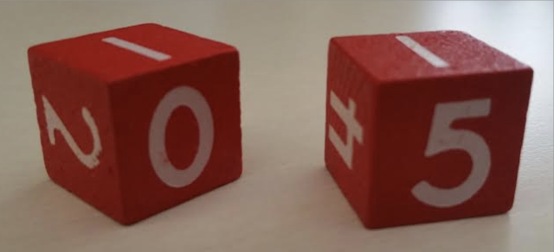  25 blue dice numbered  5-10  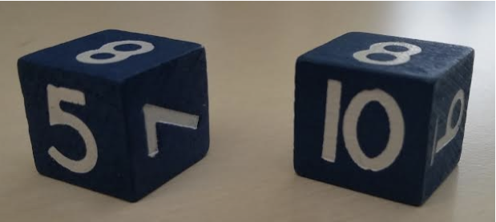
1 bag of attribute blocks  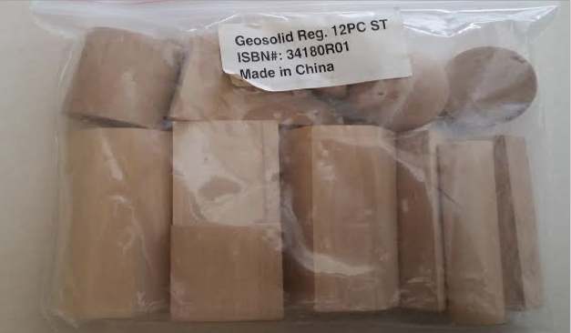 | 5 bags of wooden cubes (10 cubes in each bag)  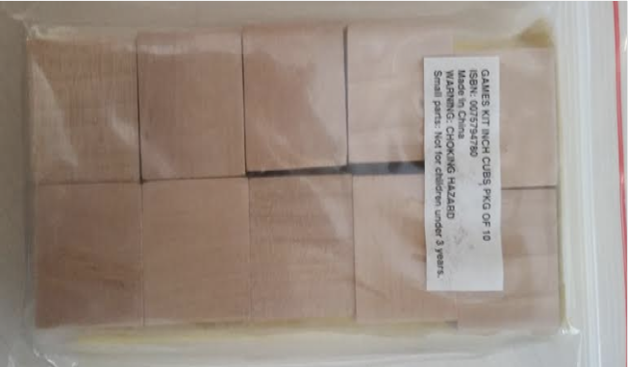 | 1 bag of pattern blocks (234 pieces total, 39 of each shape)  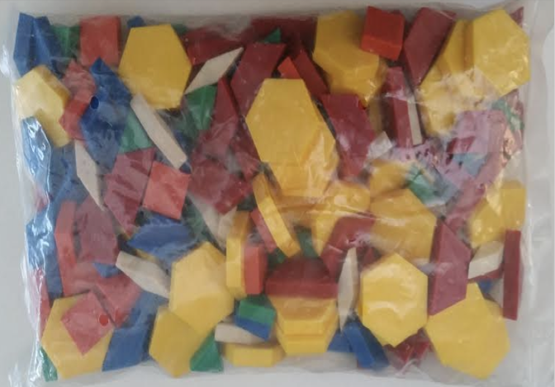 | 1 bag of flat plastic shapes  (60 pieces)  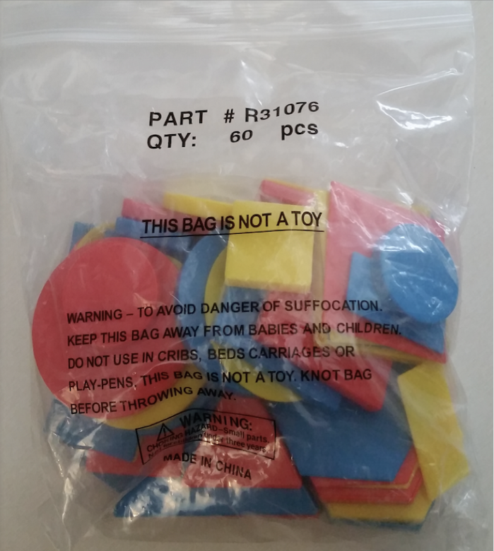 | 1 bag of two color counters  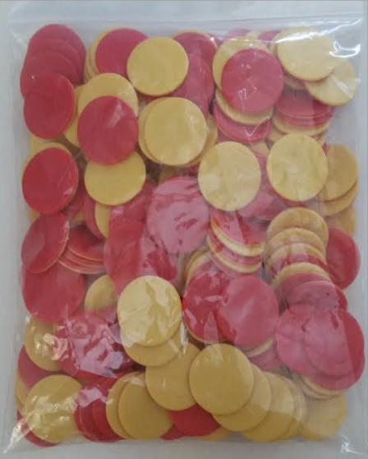
transportation counters  (144 total)  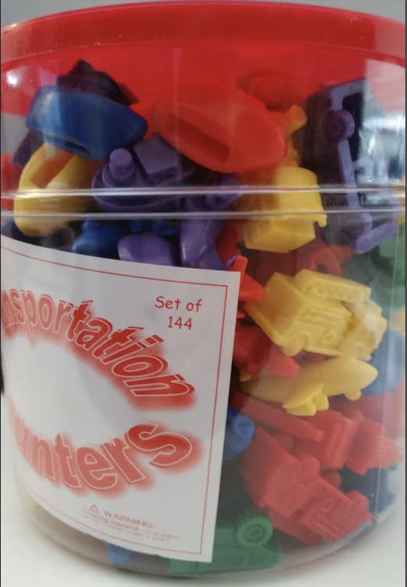 | animal counters  (144 total)  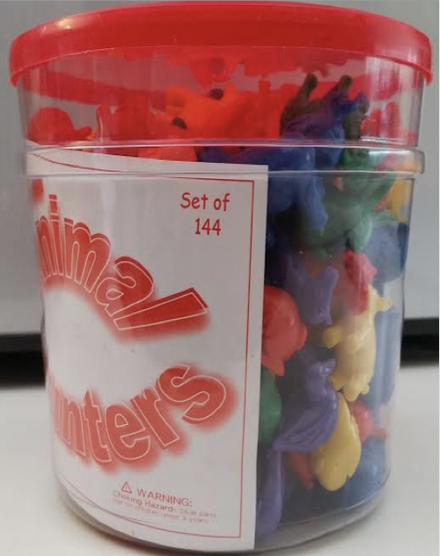 | dinosaur counters  (216 total)  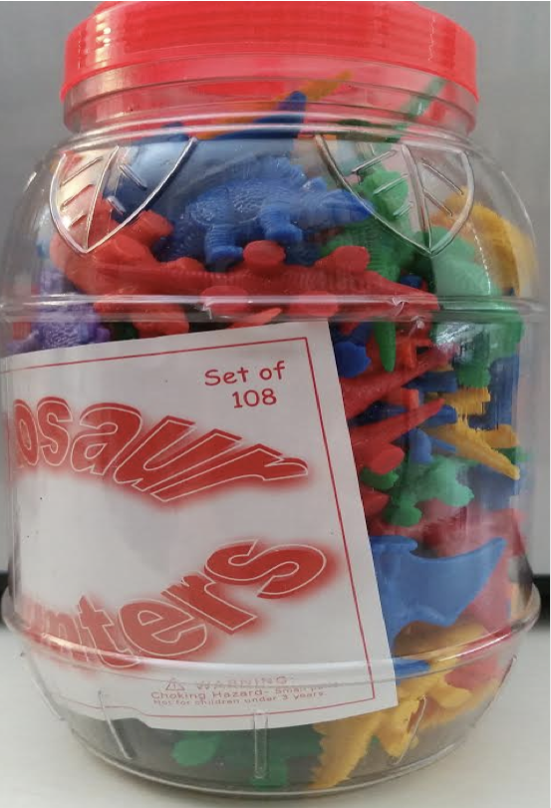 | 1 container of beads and laces  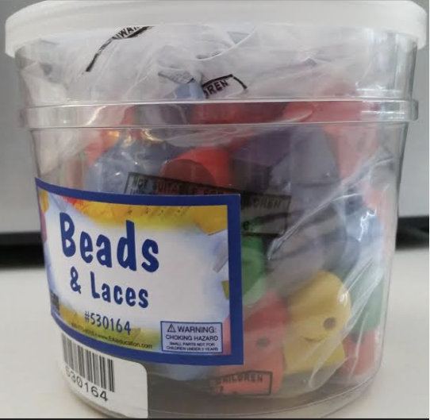 | 1 moose puppet (Mr. Mixup)  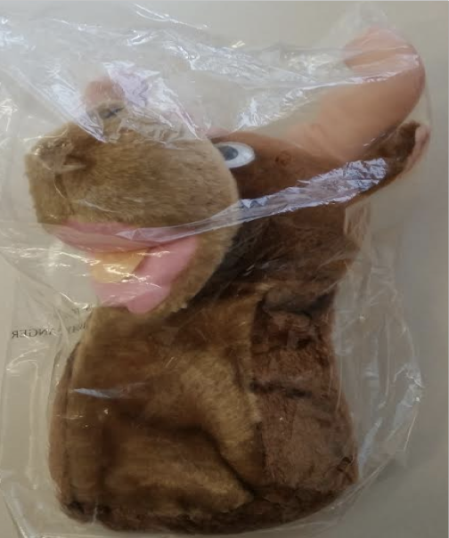

Building Blocks Big Books | Building Blocks Suggested Books
1. Where's One  2. Building Shapes  3. Victor Diego Seahawk's Big Red Wagon  4. Makayla and the Magnificent Machine | 1. The Shape of Things by Dayle Ann Dodds  2. I Spy Two Eyes by Lucy Micklethwait  3. The Right Number of Elephants by Jeff Sheppard  4. One Was Johnny by Maurice Sendak

Building Blocks Curriculum Materials, continued
Building Blocks Materials that must be made using the instructions in the Teacher’s Resource Guide
1 Shape Flip book  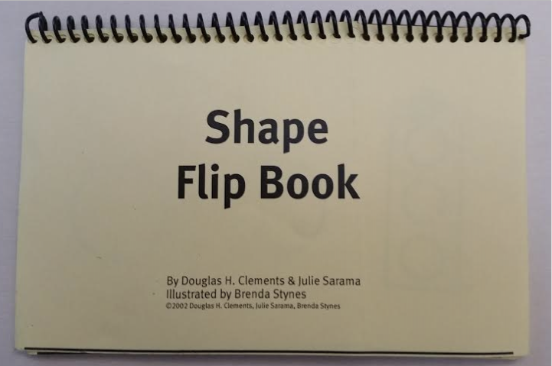 | 1 set of cut straws  (flat plastic stirrers)  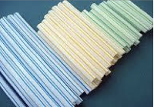 | 1 counting wand  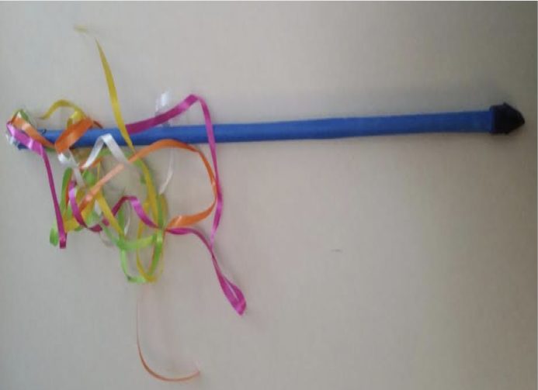

Building Blocks Materials that must be made or re-purposed from in-class materials
feely box  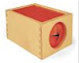 | 1 dark cloth (like felt)  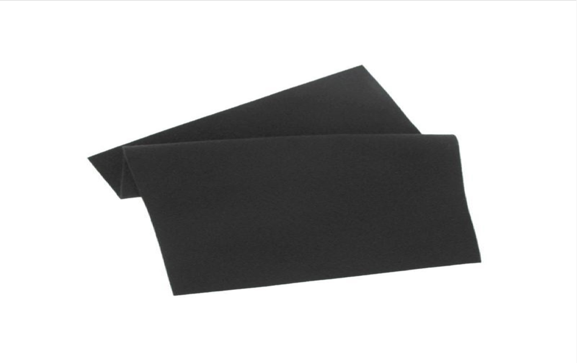 | 8-10 paper plates  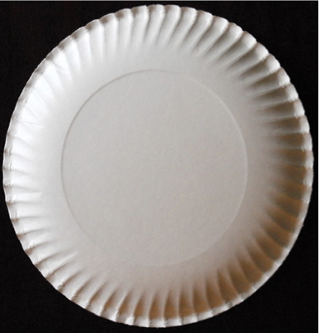 | 8-10 solo cups  (not see-through)  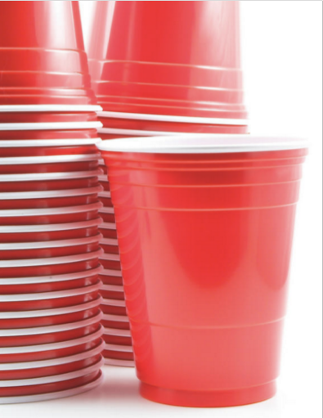
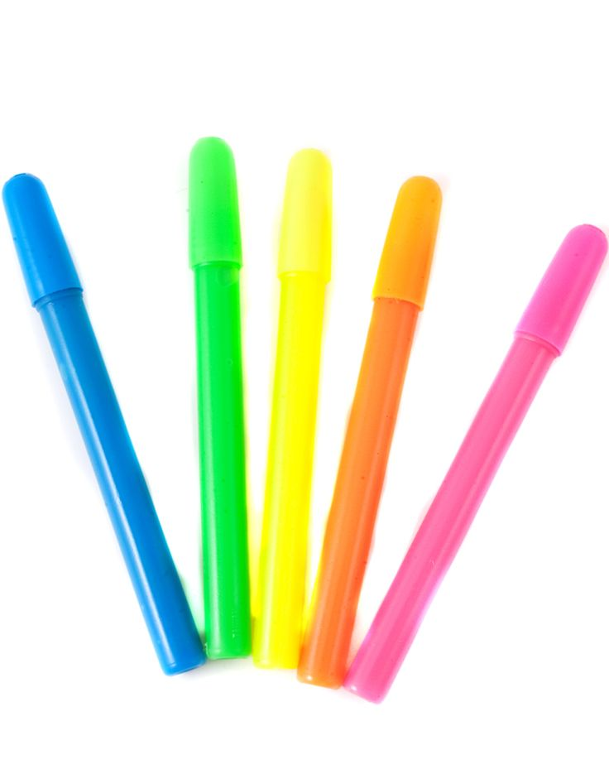  5 markers | 2 rolls of painter’s tape  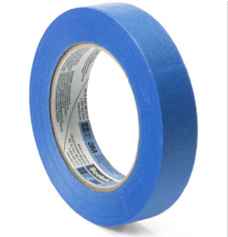 | 5 sheets of dot stickers | 8-10 sheets of paper  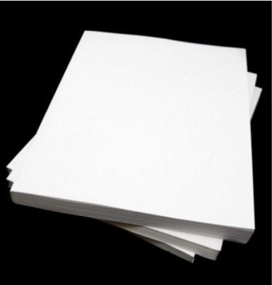

Building Block Materials that must be copied from the Teacher Resource Guide
7 sets of Numeral Cards, 1-10 Pattern Tags
7 sets of Counting Cards, 1-10 Pattern Block Cut Outs
1 set of Places Scene pictures 1 set of Pattern Block Puzzles
7 sets of Dot Cards 1-10 Tangram puzzles
6 sets of Memory Geometry cards (set A) Shape Transparencies
6 sets of Memory Geometry cards (set B) Designs for Shape Transparencies
6 sets of Memory Geometry cards (set C) Memory Geometry template
6 sets of Memory Geometry cards (set D) Pizza Game 1 template
Pattern Strips (shapes) Pizza Game 2 template
Pattern Strips (lines)

